**AWS Installation Guide:**

**Required Software’s:**

* **Putty**- To Start or Shutdown Website
* **Puttygen**- One Time Installation
* **Winscp** -To upload the Website Code on AWS Cloud

**Putty:**

* Browse for putty download

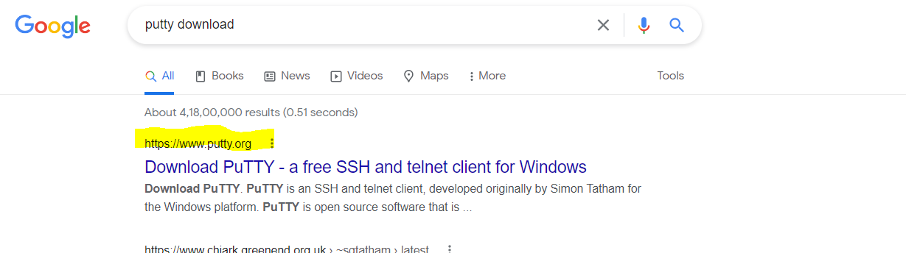

* Click on download putty link

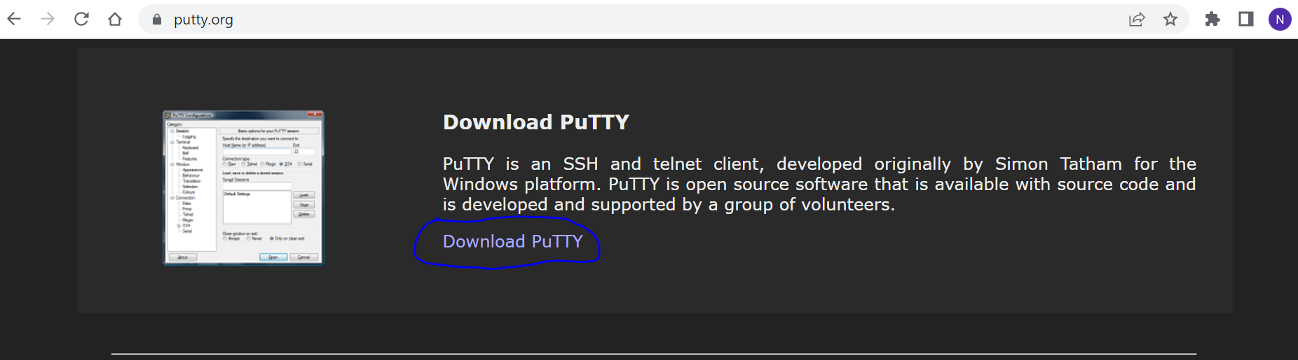

* Select 64-bit and download the .exe file

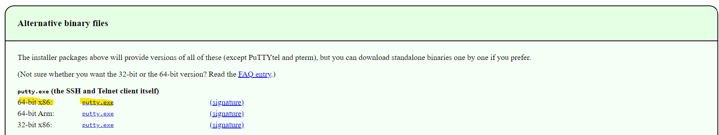

Note:

Keep all Software in the Dedicated folder

**Puttygen :**

*This Software is used to convert the Certificate file*

* **Search for Puttyen Software**

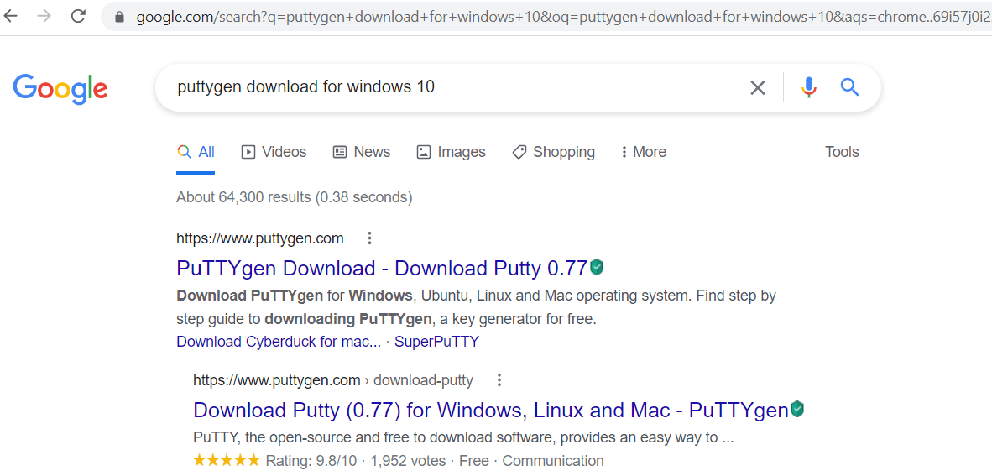

* **Click on the first link**

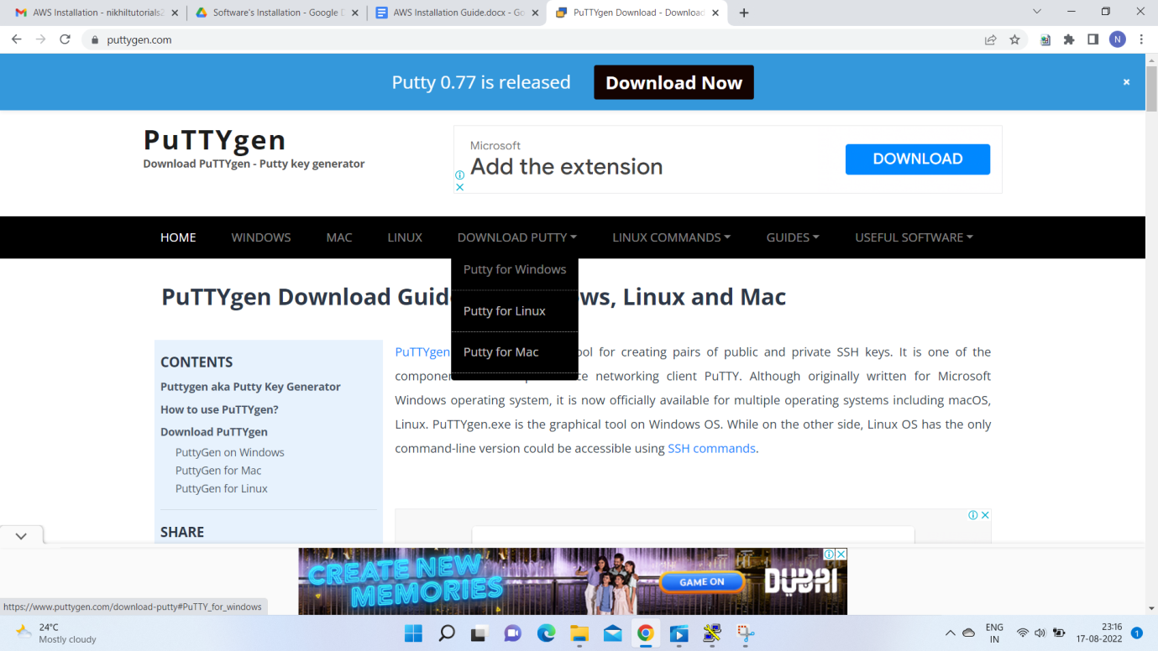

* **Select Putty for Windows from the dropdown list**
* 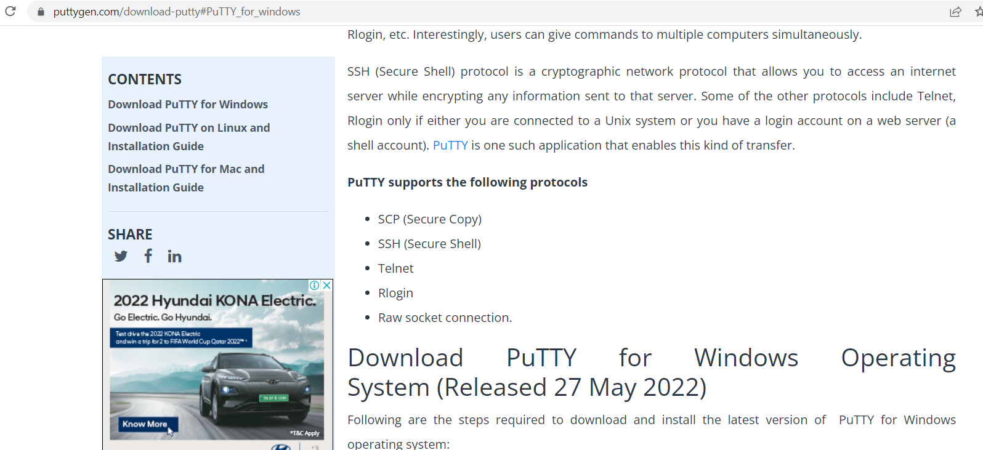
* **Search for Puttygen.exe file**

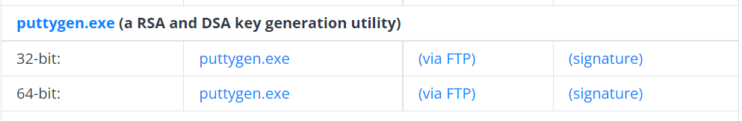

* **Click on the 64-bit puttygen.exe file and download**

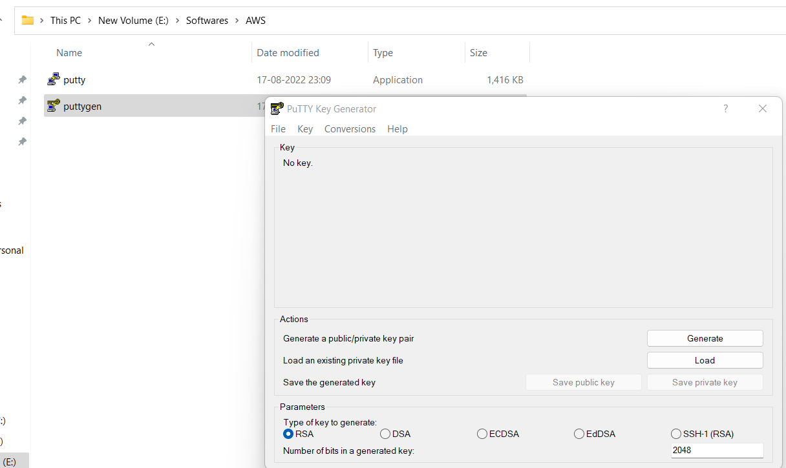

**Winscp Installation**

*This Software is used to upload the Website Code to AWS Cloud*

* **Browser for the winscp software**

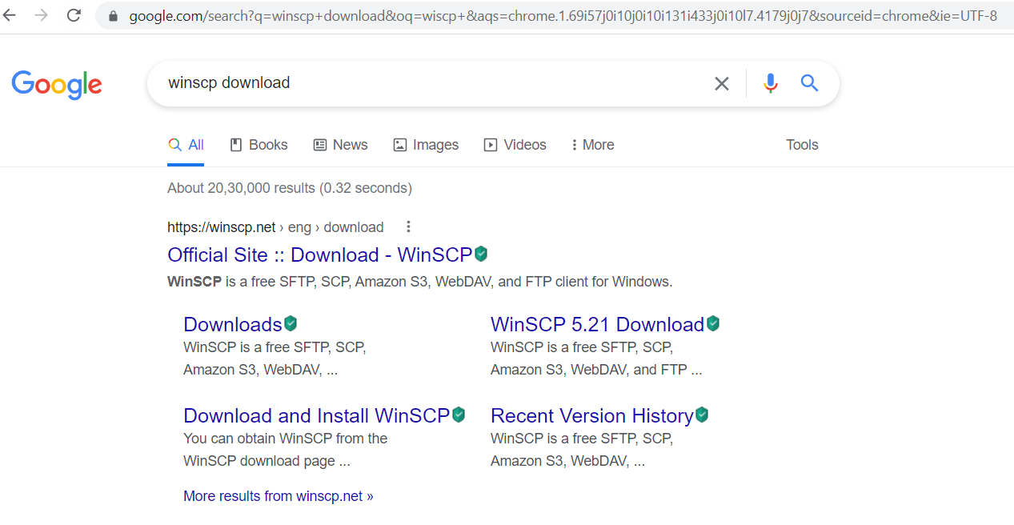

* **Click on the first result link**

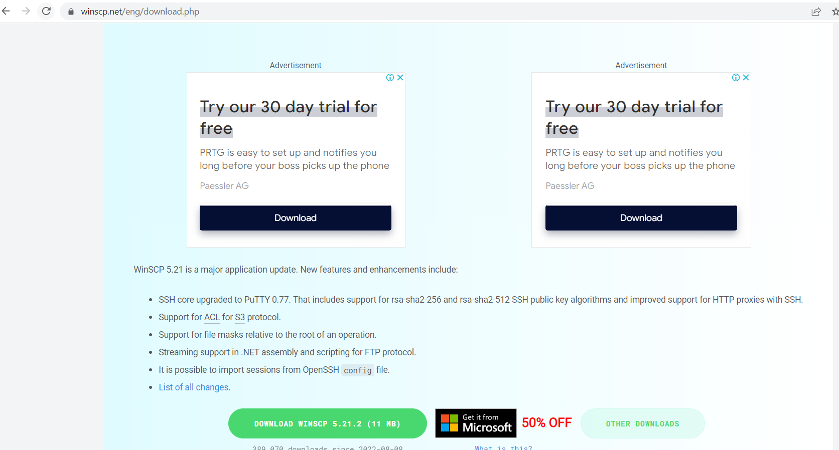

* **Click on the download Button Highlighted**

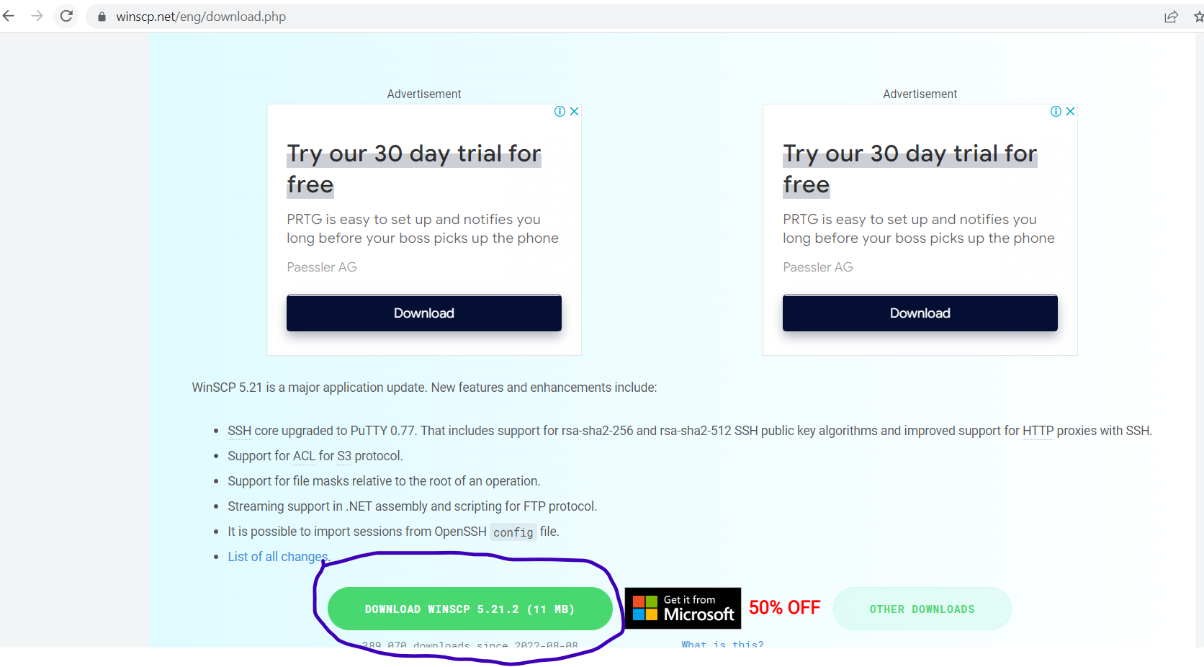

* **Verify required Software is downloaded Successfully**

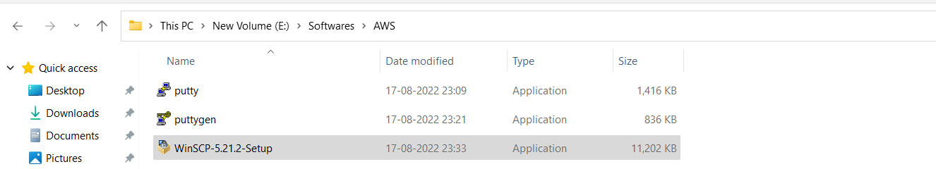

* **Install the WinSCP Software**

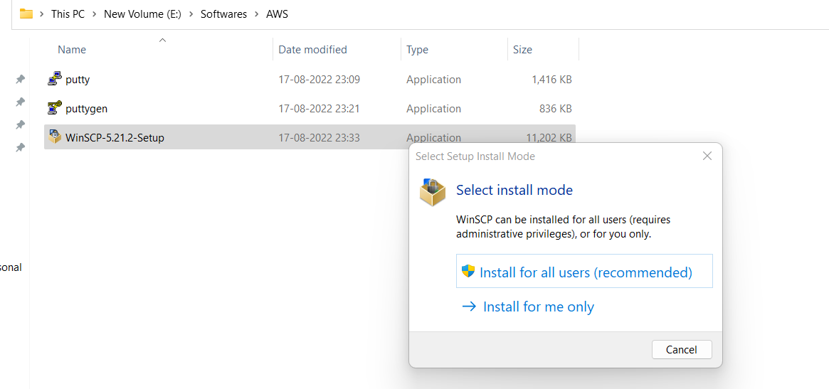

* **Select the Install for All Users option**

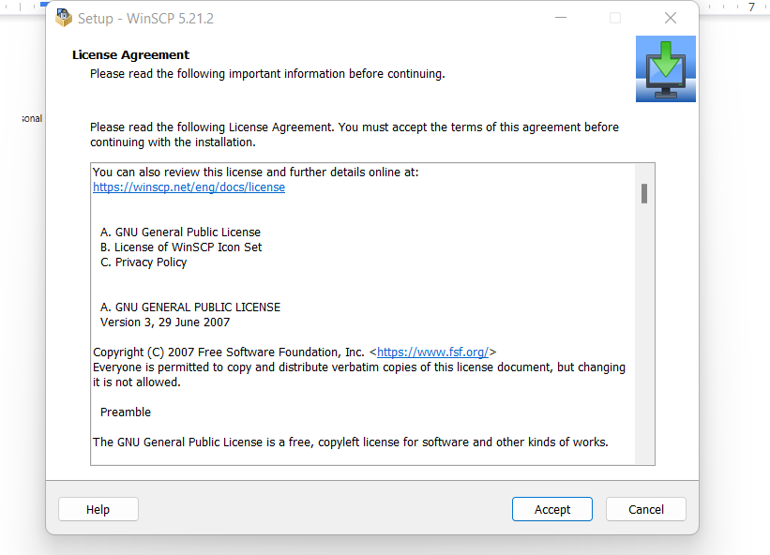

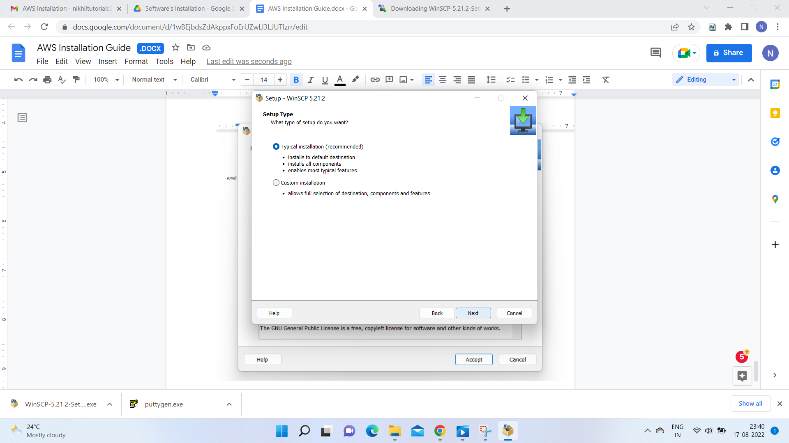

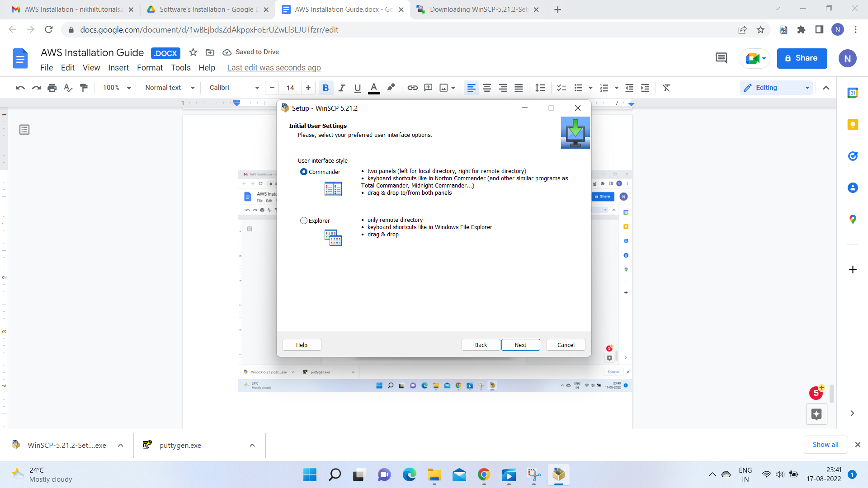

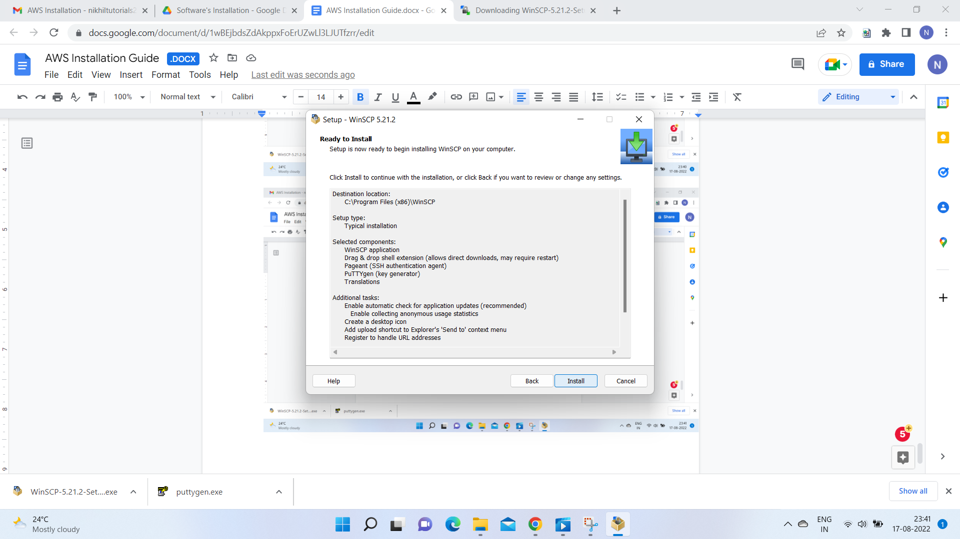

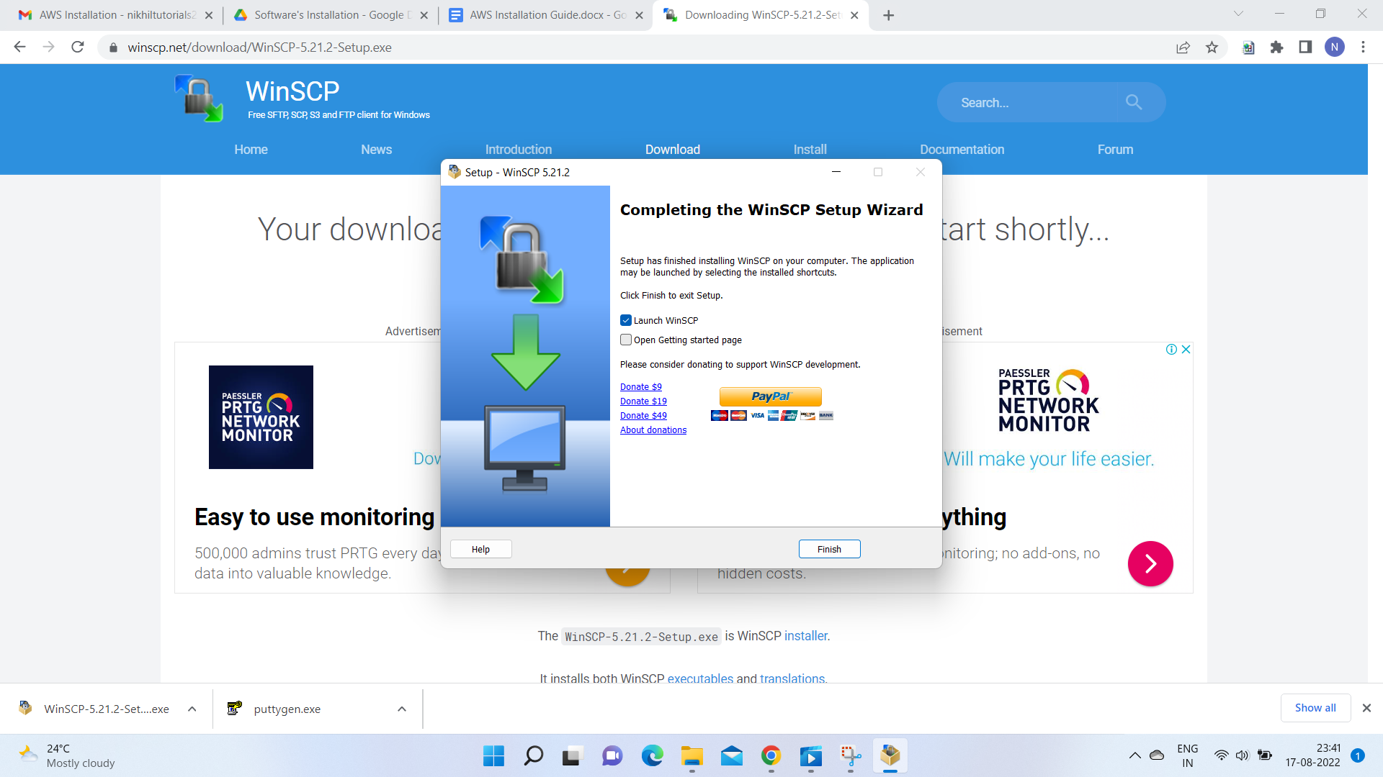

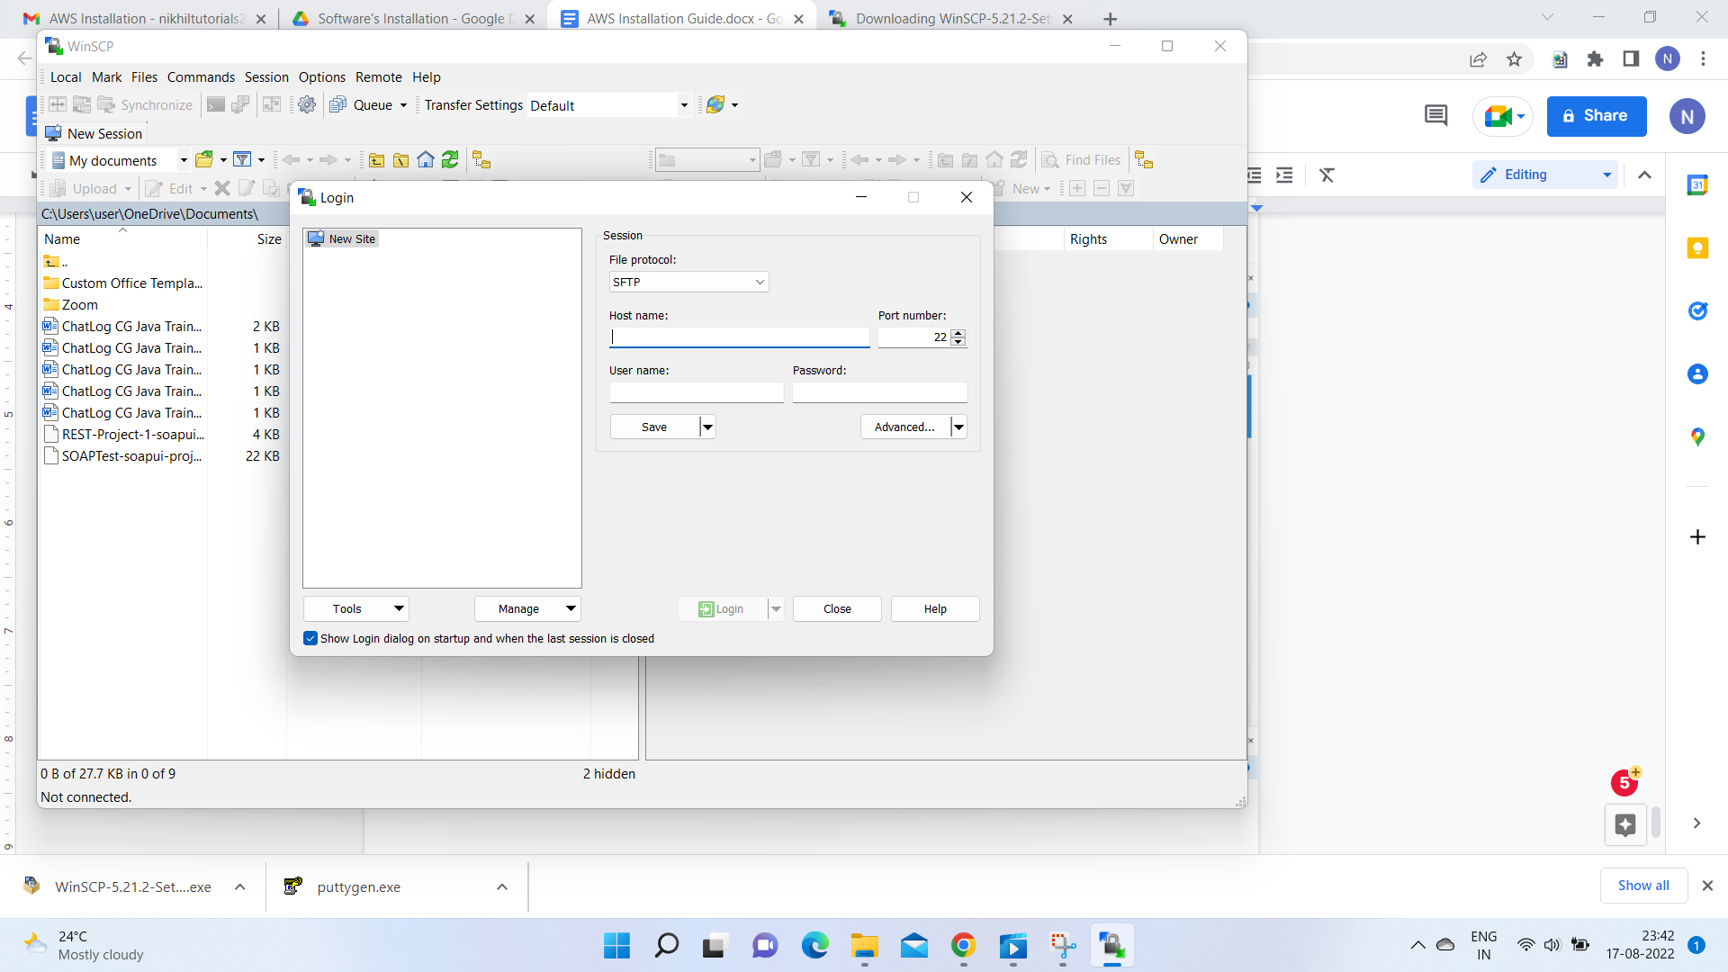

**AWS Installation**

* **Search for AWS Login**

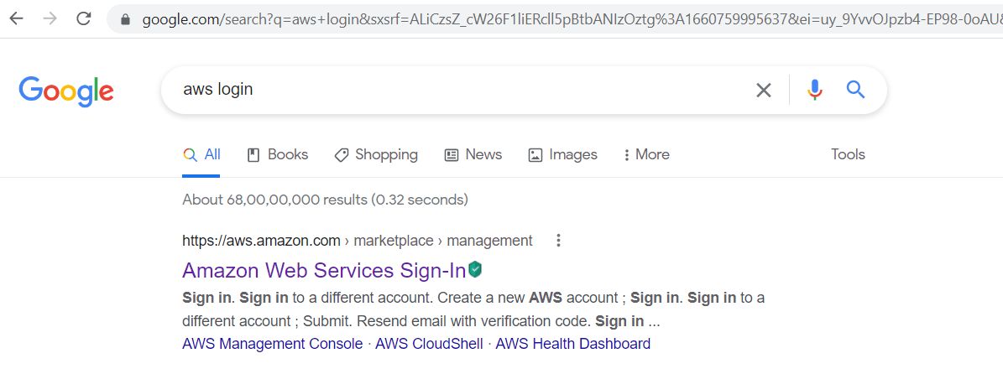

* **Select the first search result link**

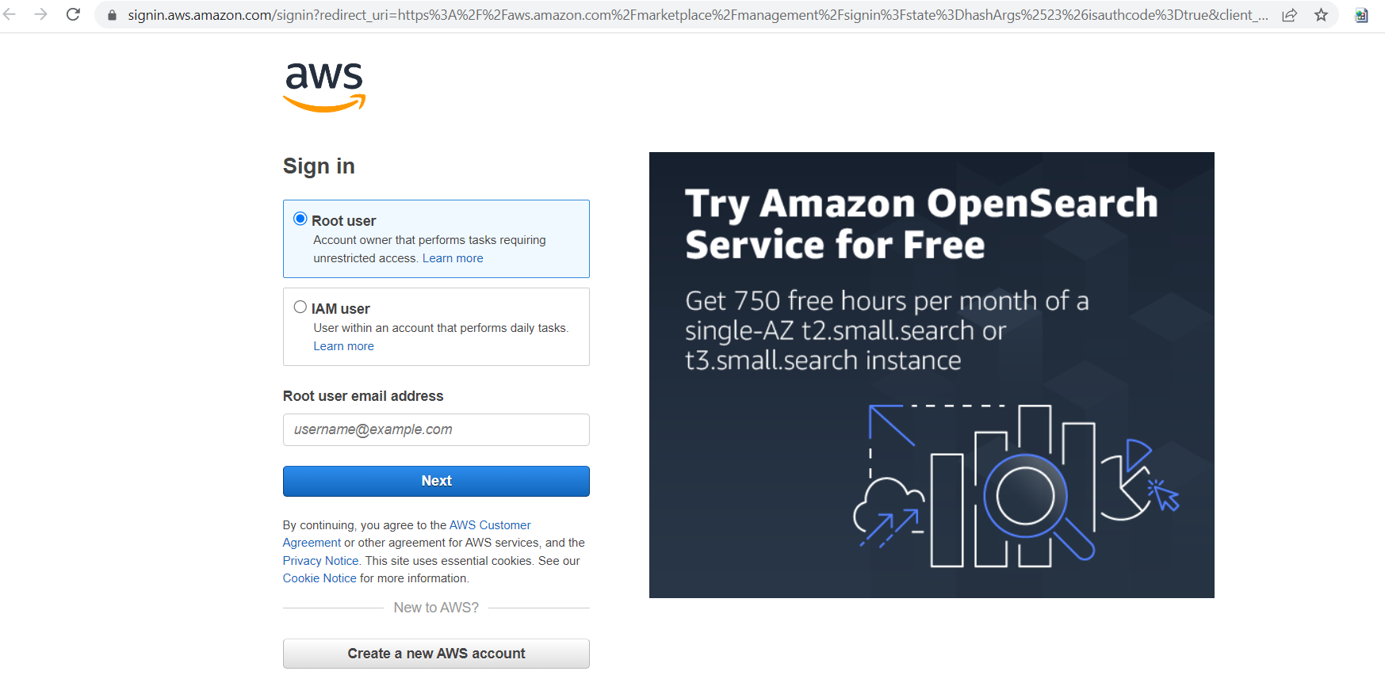

* **Click on Create a New AWS Account Button**

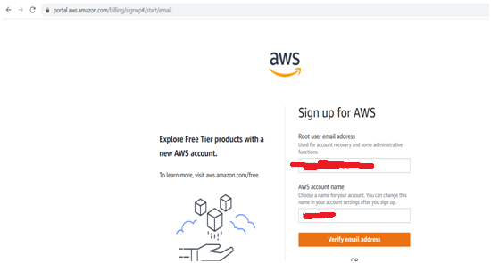

* **Verify your account by entering the Verification Code**

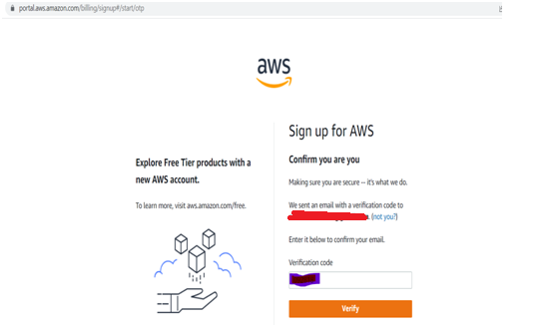

* **Enter the new Password**
* 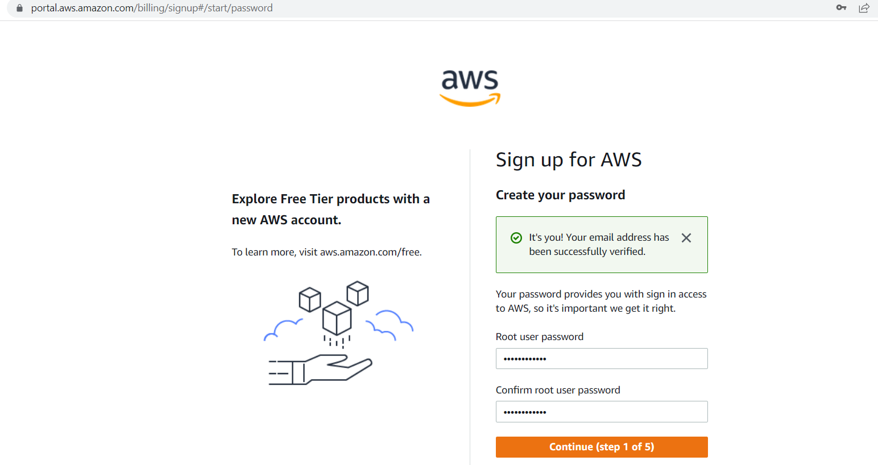
* **Select Personal Option and fill in the required details**

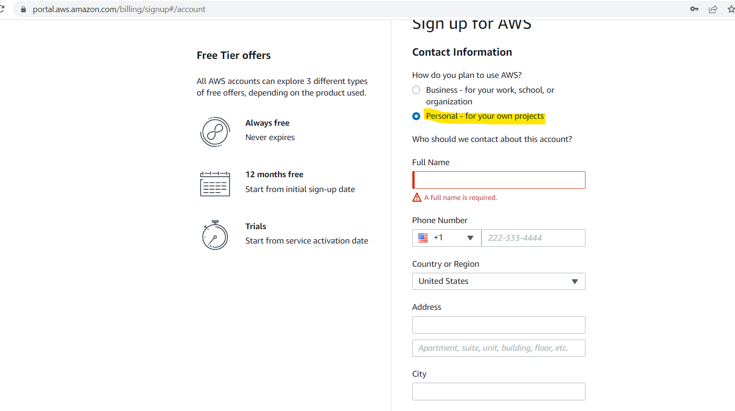

* **Fill out the Payment Details and Submit**

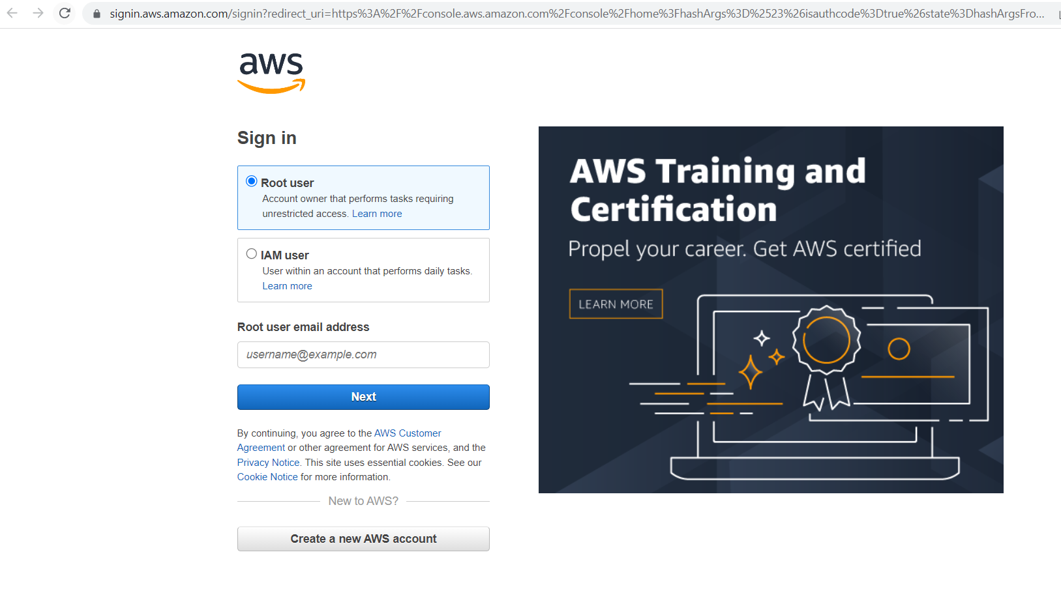

* **Login into AWS Account**

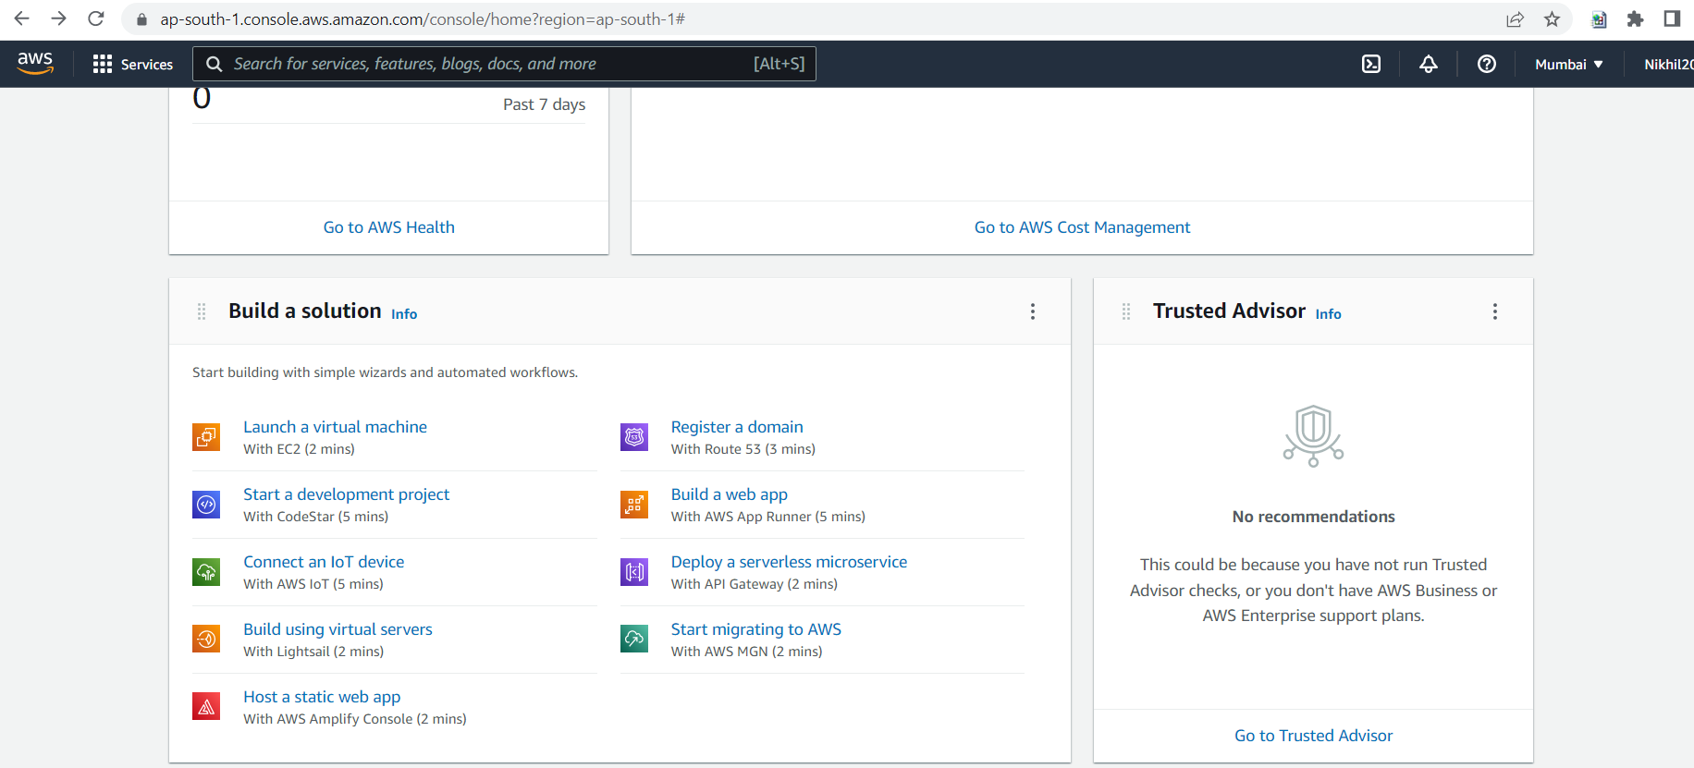

* **Select Launch a Virtual Machine with EC2 Option**

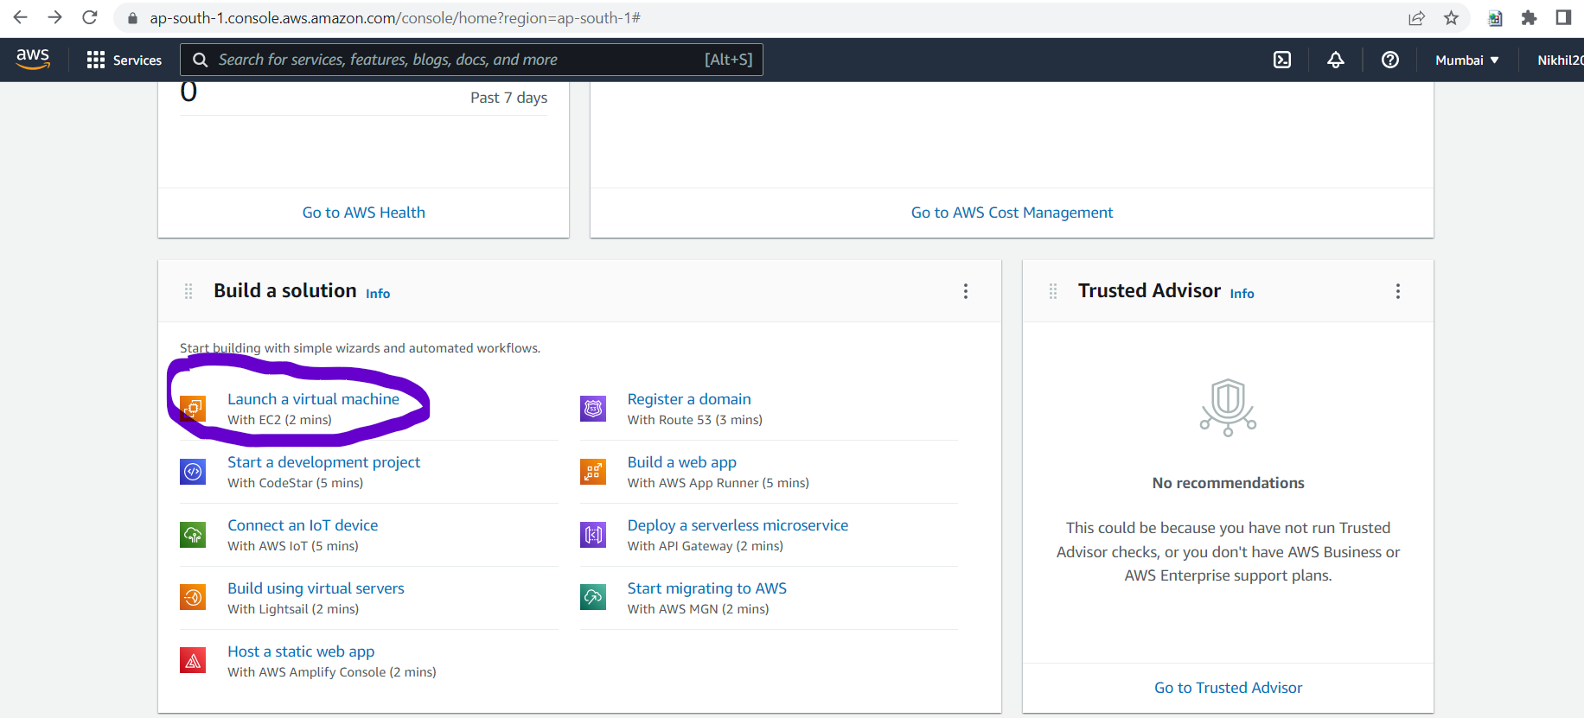

* **Select Machine which is having Java and SQL Installed**

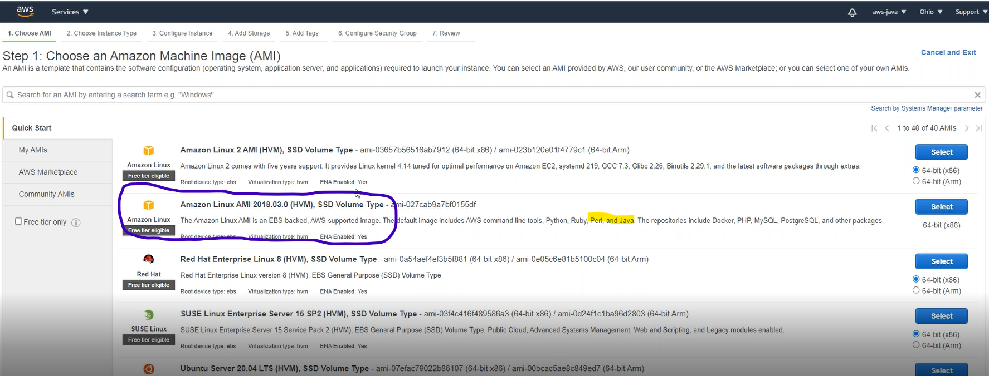

**Click Next**

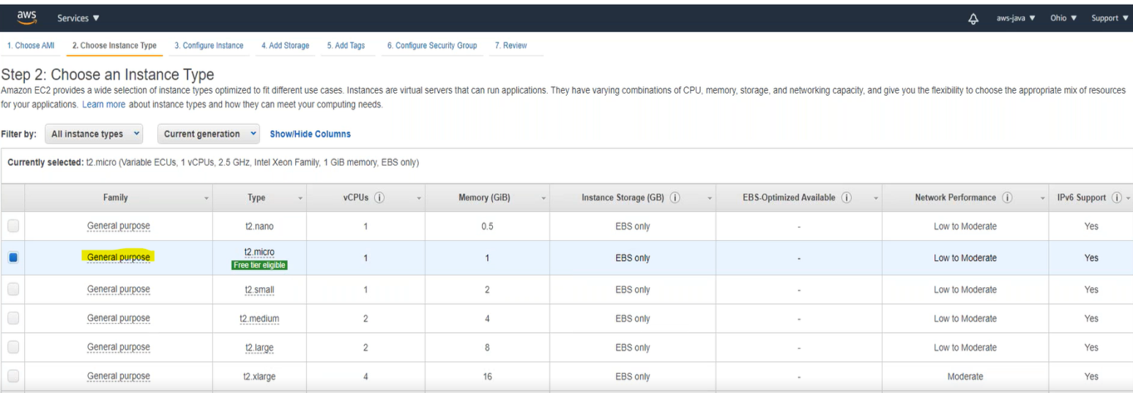

**Click Next**

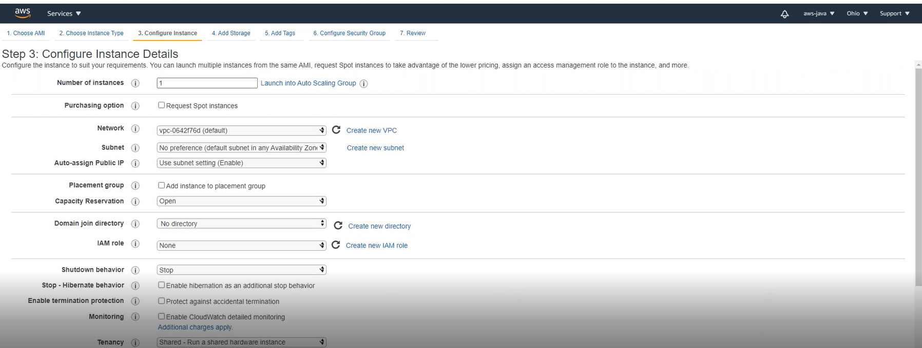

**Click Next**

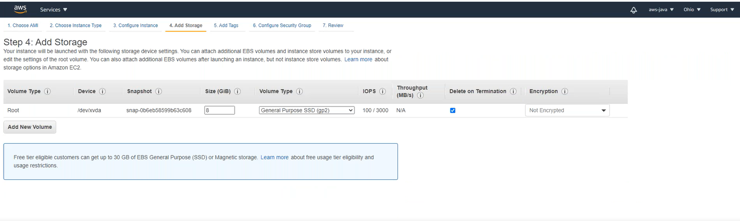

**Click Next**

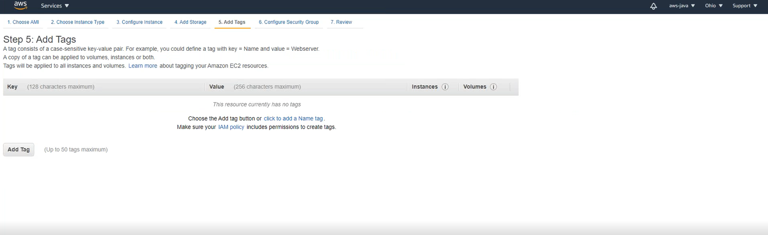

* **Click Add Rule and enter 4 settings as shown below**

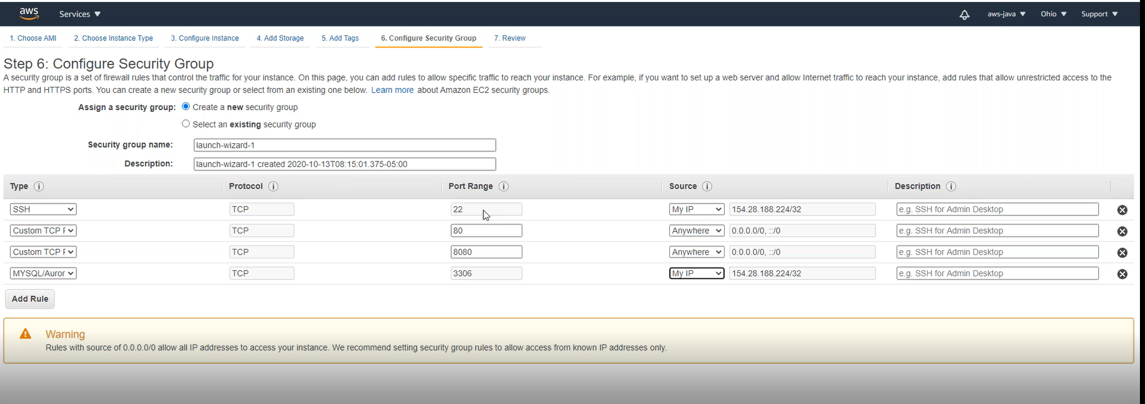

* **Click on Review and Launch**
* **An option for Key pair will be displayed.**
* **click "create new key pair" in drop down menu**
* **enter key pair name as – java**
* **click "download key-pair" ( REMEMBER WHERE java.pem IS DOWNLOADED)**
* **click launch instances.**

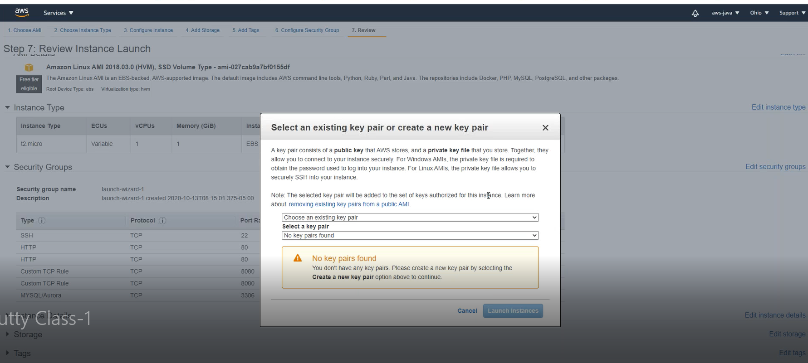

**\*\*\*\*\*\*\*\*\*CONFIGURING PUTTY AND WINSCP FOR AWS USAGE\*\*\*\*\*\*\*\*\***

* open puttygen.exe
* click load > beside File name > select drop down menu "All Files"
* then browse to where java.pem is downloaded
* and click open
* click ok on popup
* enter keyphrase - java
* entery confirm keyphrase - java
* click save private key
* enter filename as java
  + this will save a file called "java.ppk" **(REMEMBER WHERE THIS FILE IS DOWNLOADED)**
* ******* PUTTY CONFIGURATION ******
  + open putty.exe
  + in host name enter aws public ipv4 dns
  + left side click connection>ssh>auth>browse
  + select "java.ppk" file (whereever u generated above in puttygen step)
  + left slide scroll up and click on session
  + in saved session enter "aws"
  + click save
  + click open
  + click yes
  + enter login id as ec2-user
  + enter passphrase as java and then hit enter( it will not show , when ur typing)

*******install java******

* + upon login in putty window black screen enter below command
  + sudo amazon-linux-extras install java-openjdk11
    - when asked enter "y"
  + java -version

*******install mysql******

* + sudo wget https://dev.mysql.com/get/mysql57-community-release-el7-11.noarch.rpm
  + sudo yum localinstall mysql57-community-release-el7-11.noarch.rpm
  + sudo yum install mysql-community-server

******************** winscp SETUP ******

* open downloaded winscp.exe file
  + complete installation
  + click tool > import sites > import from putty > click aws and ok

******************** upload website code ******

* Spring tool suite editor
  + on JEE project > right click on pom.xml > run as > maven install
  + after console prints "build success" u can proceed with below steps
* open winscp
  + double click on aws
  + enter userid ec2-user , enter password as java
  + left side navigate to target folder of your project ( right click on projct > properties > resources > find location of your project)
  + drag and drop .war file to right side window
* open putty
  + click aws > click load > click open
  + enter userid ec2-user, enter password java
  + enter command (whatever your war file name is) - stop command followed by start command
    - sudo kill $(ps aux | grep 'java' | awk '{print $2}')
    - sudo nohup java -jar xxxx.war &
* open browser
  + type url
  + ecx-x-x-x-x.us-xxxx-2.compute.amazonaws.com